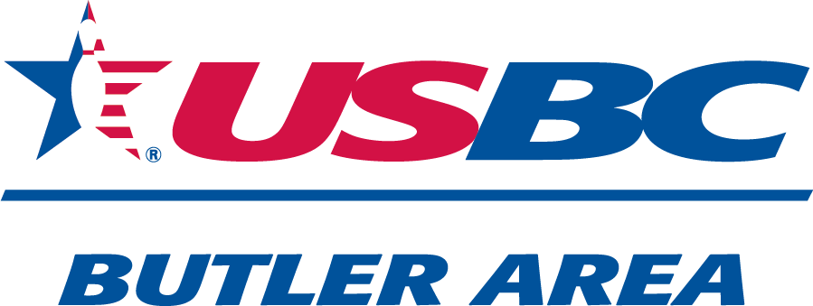
MIXED
OPEN
&$25
Entry
Fee

WOMEN ONLY DIVISIONS
- One MALE , One FEMALE -
DOUBLES TOURNAMENT
$1,000 First Place Prize
Based on Full sSquadTournament
3 Games Qualifying
Then elimination format
$ 90.00
Entry Fee per team

March 1st
10:30 am
Sherwood Lanes
11 Lyn-mar plaza
Lyndora,Pa

*Applications at front counter*
*Limited Spots Available*
Tournament Sponsors: Butler Area USBC, Peg Leg Proshop, Rankin Welding,
Sherwood Lanes, Industry Terminal & Salvage Co., Lorenz Motors,
Nate's Custom Carpentry, C. Mathue Solutions, Troy-Alan Chevrolet
Neil Morris 724-991-8424

