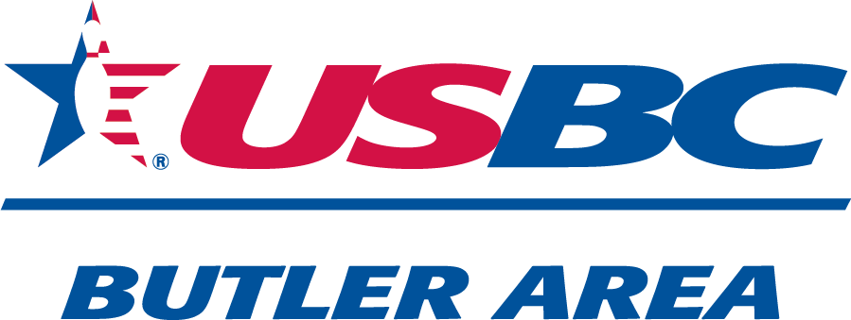
SPONSORS:
Peg Leg Pro-Shop
Rankin Welding
Affordable Graphics
Moose Tree Service
SPONSORS:
Butler Area USBC
Vic-Nor Farms
Industry Terminal & Salvage
Lorenz Motors

2025-2026
OPEN
&
WOMEN ONLY DIVISIONS

Womens Only

DOUBLES TOURNAMENT
9:00 am
&
1:00 pm

Sunday March 8th

Sunday March 15th
Bowl-o-Drome
Bowling Alley
is
B.Y.O.B
$60
Entry
Fee
540 E Main St Ext, Grove City, PA 16127
*Applications at front counter*
Limited Spots Available

