Butler Area Bowling Association
Over-Under 50 Tournament

1. Those eligible to bowl in the tournament are:
a. All Butler Area USBC members.
b. All military personnel who are residents of Butler County without an USBC card will purchase an affiliate membership card for $22.00 and will bowl scratch.
c. Non-members of the USBC, living within the jurisdiction of this Association, may enter by buying an affiliate membership card for $22.00 and will bowl scratch.
d. USBC members from another association may cross sanction for $7.00 to BAUSBC.
2. Entrants will use their highest USBC sanctioned league average based on a minimum of 21 games from the previous season. If there is no average from the previous year, use the highest current USBC sanctioned average, 21 games or more, as of the time of bowling. All others will bowl scratch.
3. It shall be the bowler's responsibility to determine that the average is correct. Failure to use the proper average shall disqualify the score if the submitted average is lower than actual average thereby resulting in more handicap or base prize winnings on submitted average if it is higher. Familiarize yourself with USBC rule 319D & 319E.
a. Ten Pin Rule will be observed 319A-2: When the previous season’s average is used, and at the time of bowling an entrant has a current average for 21 or more games that is 10 pins or more higher than the prior season’s average, the current average must be used.
4. Handicap for the tournament will be based on 90% of the difference between Individual entering average and 230.
5. Tournament management will make lane assignments.
6. In the event of a lane breakdown, the tournament directors reserve the right to move bowlers to other lanes, and the match will continue from the point of the breakdown.
7. There shall be 10 minutes of practice to start the tournament.
8. Open practice shall not be allowed on lanes scheduled for use in the tournament that day.
9. Bowlers arriving late will begin play with the frame being bowled. Missed frames cannot be made up and will be scored as zero.
10. This is a handicapped tournament.
11. All prize money will be returned 100%.
a. The guaranteed first place prize fund is guaranteed if only 44 teams fill the squad.
12. In the case of a tie in any position, prize money for those positions will be combined and divided equally.
13. All entry money must accompany an application.
a. Contestant MUST list birthday on the applications.
b. Contestants must list USBC sanction number.
c. No one will be entitled to any refund after entry fees have been submitted.
14. Each bowler will bowl 3 games, then Eliminator playoff format to determine winner.
15. All bowlers must check in 30 minutes prior to the starting time and show their USBC membership card. Walk-in entries will not be accepted. (Tournament directors’ discretion.)
16. All entries mailed must be postmarked by midnight Tuesday prior to the bowling date.
17. Lanes shall be dressed prior to the tournament.
a. The shot will not be the typical house shot.
18. USBC Awards shall be awarded.
19. If a situation occurs and is not covered under any Butler Area USBC tournament rules, USBC RULES WILL APPLY.
20. Teams will consist of 2 bowlers, regardless of gender.
a. ONE bowler must be an ACTIVE BOWLER OF BAUSBC.
*Active bowler = on a roster inside the association with established average*
b. One bowler must be 50 years old or over the date of the tournament.
One bowler must be 49 years old or younger on the date of the tournament.

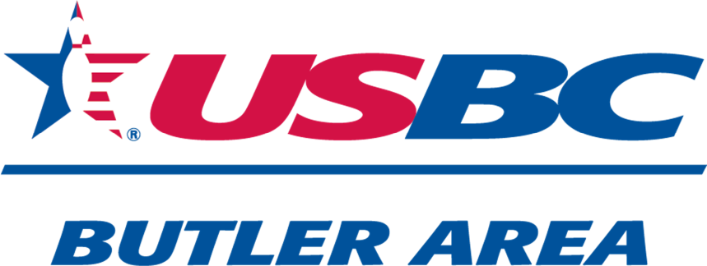

Over/ Under 50
$1,000 FIRST PLACE Guaranteed
Based on a full squad
December 14th, 2025
10:30 am
Sherwood Lanes
11 Lyn-Mar Plaza
Lyndora, Pa
16045

Bowler Name:
Birthday:
Sanction Number:
Average 2024-2025:
Bowler Name:
Birthday:
Sanction Number:
Average 2024-2025:
Cost Per Person $45.00
TOTAL $90.00 TOTAL ENCLOSED $
Mail to: PHONE 724-991-8424
Butler Area USBC
C/O Neil Morris
117 Stoney Batter Road EMAILButlerAreaUSBC@gmail.com
Prospect, Pa 16052

