Butler Area Bowling Association
Mixed Doubles Tournament

1. Those eligible to bowl in the tournament are:
a. All Butler Area USBC members.
b. All military personnel who are residents of Butler County without an USBC card will purchase an affiliate membership card for $22.00 and will bowl scratch.
c. Non-members of the USBC, may enter by buying an affiliate membership card for $22.00 and will bowl scratch.
d. USBC members from another association may cross sanction for $7.00 to BAUSBC.
2. Entrants will use their highest USBC sanctioned league average based on a minimum of 21 games from the previous season. If no average from the previous year, use the highest current USBC sanctioned average, 21 games or more, as of the time of bowling. All others will bowl scratch.
3. It shall be the bowler's responsibility to determine that the average is correct. Failure to use the proper average shall disqualify the score if the submitted average is lower than actual average thereby resulting in more handicap or base prize winnings on submitted average if it is higher. Familiarize yourself with USBC rule 319D & 319E.
a. Ten Pin Rule will be observed 319A-2: When the previous season’s average is used, and at the time of bowling an entrant has a current average for 21 or more games that is 10 pins or more higher than the prior season’s average, the current average must be used.
4. Handicap for the tournament will be based on 90% of the difference between team combined average and 450
5. Tournament management will make lane assignments.
6.In the event of a lane breakdown, the tournament directors reserve the right to move bowlers to other lanes and the match will continue from the point of the breakdown.
7. There shall be 10 minutes of practice to start the tournament.
8. Open practice shall not be allowed on lanes scheduled for use in the tournament that day.
9. Bowlers arriving late will begin play with the frame being bowled. Missed frames cannot be made up and will be scored as zero.
10. This is a handicapped tournament.
11. All prize money will be returned 100%.
a. The guaranteed first place prize fund is guaranteed only if it is a full squad.
12. In the case of a tie:
a. First cut – both teams will advance to the next round.
b. Second cut and beyond - there will be a 9th and 10th frame roll off
13. All entry money must accompany an application.
a. Contestants must list USBC sanction number.
b. No one will be entitled to any refund after entry fees have been submitted
14. Each bowler will bowl 3 games, then Eliminator playoff format to determine winner.
15. All bowlers must check in 30 minutes prior to the starting time and show their USBC membership card. Walk-in entries will not be accepted. (Tournament director’s discretion.)
16. All entries mailed must be postmarked by midnight Tuesday prior to the bowling date.
17. Lanes shall be dressed prior to the tournament. (The final match will be on fresh oil.)
18. USBC Awards shall be awarded.
19. If a situation occurs and is not covered under any Butler Area USBC tournament rules, USBC RULES WILL APPLY. Tournament Director has final decision.
20. Teams will consist of 2 bowlers, REGARDLESS OF ASSOCIATION.
a. One bowler must be male. One must be female.
b. ONLY ONE CARD CARRYING PRO, PER TEAM.

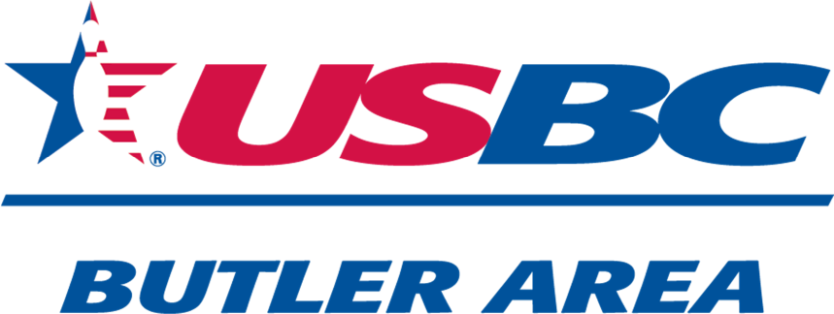

Mixed Doubles
$1,000 First Place Guaranteed
(with full squad)
March 1, 2026
10:30 am
Sherwood Lanes
11 Lynn-Mar Plaza
Lyndora,Pa
16001

Bowler Name:
Sanction Number:
Average 2024-2025:
Bowler Name:
Sanction Number:
Average 2024-2025

Cost Per Person $45.00
TOTAL $90.00 TOTAL ENCLOSED $
Mail to: PHONE 724-991-8424
Butler Area USBC
C/O Neil Morris
117 Stoney Batter Road EMAILButlerAreaUSBC@gmail.com
Prospect,Pa 16052

