Butler Area Bowling Association
Scratch Classic

1. Those eligible to bowl in the tournament are:
a. All Butler Area USBC members.
b. All military personnel who are residents of Butler County without an USBC card will purchase an affiliate membership card for $22.00 and will bowl scratch.
c. Non-members of the USBC, living within the jurisdiction of this Association, may enter by buying an affiliate membership card for $22.00 and will bowl scratch.
d. USBC members from another association may cross sanction for $7.00 to BAUSBC.
5. Tournament management will make lane assignments.
6.In the event of a lane breakdown, the tournament directors reserve the right to move bowlers to other lanes and the match will continue from the point of the breakdown.
7. There shall be 10 minutes of practice to start the tournament.
8. Open practice shall not be allowed on lanes scheduled for use in the tournament that day.
9. Bowlers arriving late will begin play with the frame being bowled. Missed frames cannot be made up and will be scored as zero.
10. This is a Scratch tournament.
11. All prize money will be returned 100%.
a. The guaranteed first place prize fund is guaranteed only if 48 entries fill the squad.
12. In the case of a tie in any position, prize money for those positions will be combined and divided equally.
13. All entry money must accompany an application.
a. Contestants must list USBC sanction number.
b. No one will be entitled to any refund after entry fees have been submitted
14. Each bowler will bowl 3 games, then Eliminator playoff format to determine winner.
15. All bowlers must check in 30 minutes prior to the starting time and show their USBC membership card. Walk-in entries will not be accepted. (Tournament directors discretion.)
16. All entries mailed must be postmarked by midnight Tuesday prior to the bowling date.
17. Lanes shall be dressed prior to the tournament.
a. The shot will not be the typical house shot.
18. USBC Awards shall be awarded.
19. If a situation occurs and is not covered under any Butler Area USBC tournament rules, USBC RULES WILL APPLY.

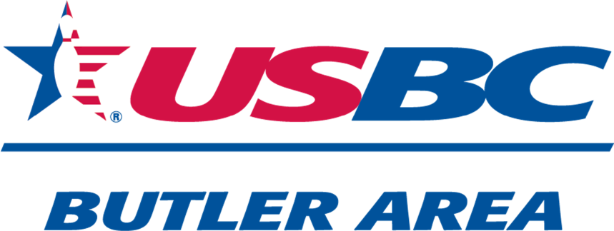

Scratch Classic
$1,000 FIRST PLACE Guaranteed
Based on a full squad
January 4th, 2026
10:00 am
Belmont II Lanes
1805 North Main Street Ext.
Butler,Pa
16001

Bowler Name:

Sanction Number:

SPECIAL THANKS TO SPONSORS:
Bill Errera Sales and Services Inc
Stateline Bar and Grill
Nate’s Custom Carpentry
C Mauthe Solutions

TOTAL $75.00 TOTAL ENCLOSED $
Mail to: PHONE 724-991-8424
Butler Area USBC
C/O Neil Morris
117 Stoney Batter Road EMAILButlerAreaUSBC@gmail.com
Prospect,Pa 16052

